Assignment 1

Name: Parth Koshti
PRN: 24070126093
Batch: AIML B1

Arithmatic Operations Code

import java.util.Scanner;

public class Assignment1 {
public int num1, num2;

public int addNums(int n1, int n2) {
return n1 + n2;
}

public int SubNums(int n1, int n2) {
return n1 - n2;
}

public int MulNums(int n1, int n2) {
return n1 * n2;
}

public float DivNums(int n1, int n2) {
return n1 / n2;
}

public int CalMod(int n1, int n2) {
return n1 % n2;
}

public static void main(String[] args) {
Scanner scanner = new Scanner(System.in);
Assignment1 op = new Assignment1();

System.out.println("Enter First Number");
op.num1 = scanner.nextInt();
System.out.println("Enter Second Number");
op.num2 = scanner.nextInt();

int sum = op.addNums(op.num1, op.num2);
int diff = op.SubNums(op.num1, op.num2);
int prod = op.MulNums(op.num1, op.num2);
float div = op.DivNums(op.num1, op.num2);
int mod = op.CalMod(op.num1, op.num2);

System.out.println("Addition = " + sum);
System.out.println("Subtraction = " + diff);
System.out.println("Multiplication = " + prod);
System.out.println("Division = " + div);
System.out.println("Modulus = " + mod);

System.out.println("Sum of the numbers: " + op.addNums(op.num1, op.num2));
System.out.println("Difference of the numbers: " + op.SubNums(op.num1, op.num2));
System.out.println("Product of the numbers: " + op.MulNums(op.num1, op.num2));
System.out.println("Division of the numbers: " + op.DivNums(op.num1, op.num2));
System.out.println("Modulus of the numbers: " + op.CalMod(op.num1, op.num2));

scanner.close();
}

}

Output:
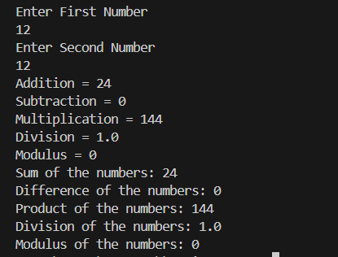

Exception:
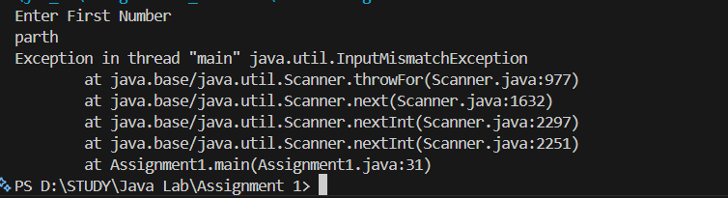
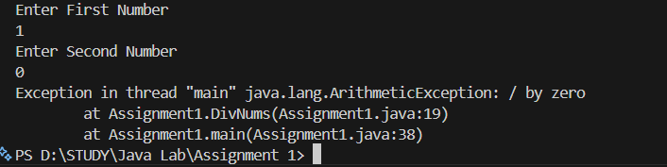

Calculator

import java.util.Scanner;

public class calculator {
public int num1, num2, op;
public int flag = 0;

public int addNums(int n1, int n2) {
return n1 + n2;
}

public int SubNums(int n1, int n2) {
return n1 - n2;
}

public int MulNums(int n1, int n2) {
return n1 * n2;
}

public float DivNums(int n1, int n2) {
return n1 / n2;
}

public int CalMod(int n1, int n2) {
return n1 % n2;
}

public static void main(String[] args) {
Scanner scanner = new Scanner(System.in);
calculator calc = new calculator();

do {
System.out.println("\nEnter First Number");
calc.num1 = scanner.nextInt();
System.out.println("Enter Second Number");
calc.num2 = scanner.nextInt();

System.out.println("Enter Operation");
System.out.println("1. Addition");
System.out.println("2. Subtraction");
System.out.println("3. Multiplication");
System.out.println("4. Division");
System.out.println("5. Modulus");
calc.op = scanner.nextInt();

switch (calc.op) {
case 1:
int sum = calc.addNums(calc.num1, calc.num2);
System.out.println("Addition = " + sum);
break;
case 2:
int diff = calc.SubNums(calc.num1, calc.num2);
System.out.println("Subtraction = " + diff);
break;
case 3:
int prod = calc.MulNums(calc.num1, calc.num2);
System.out.println("Multiplication = " + prod);
break;
case 4:
float div = calc.DivNums(calc.num1, calc.num2);
System.out.println("Division = " + div);
break;
case 5:
int mod = calc.CalMod(calc.num1, calc.num2);
System.out.println("Modulus = " + mod);
break;
default:
System.out.println("Invalid Operation - Exiting...");
calc.flag = 1;
break;
}

if (calc.flag == 0) {
System.out.print("\nDo you want to continue? (Y/N): ");
char choice = scanner.next().charAt(0);
if (choice == 'N' || choice == 'n') {
System.out.println("Bye");
calc.flag = 1;
}
}
} while (calc.flag == 0);

scanner.close();
}
}

Output:
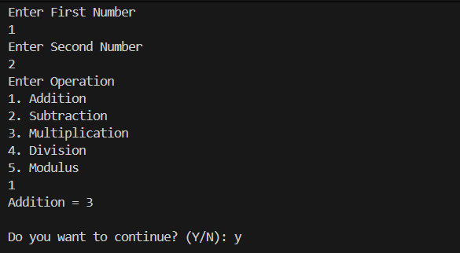

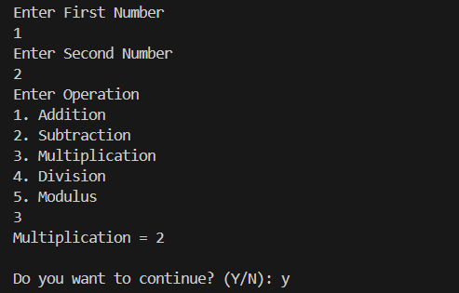

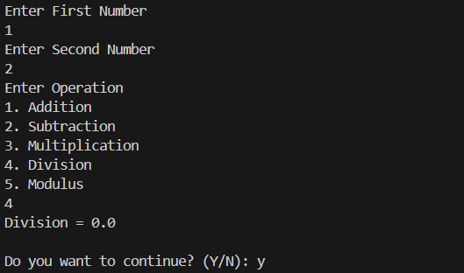

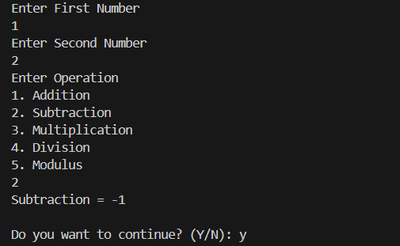

Exception:
